**Research Report**

**1. Introduction: Voice-Enabled Offline Form Filling for Remote Areas**

The "Voice Assistant for Form Filling" project aims to simplify the process of filling out forms by enabling users to input data through speech. This application, built using Python, leverages speech recognition technologies to interpret user input and populate form fields accordingly. The primary objective is to create a tool that reduces the dependency on manual typing, particularly beneficial for individuals with physical disabilities or limited typing skills.

The main use case for this application is its deployment in remote regions where internet access may be limited, enabling offline form filling. The application is designed to handle general forms that are commonly used for data entry in various settings, such as first name, last name, age, date of birth, and phone numbers. This form filling process can be applied in diverse contexts, such as health surveys, registration forms, or other data collection tasks, making it a versatile tool for data entry in any location.

**2. Libraries Used**

The project integrates various Python libraries to achieve voice-enabled form filling. Below are the key libraries used:

1. **Playsound**: Used for playing audio prompts and notifications to guide the user during the form-filling process.
2. **gTTS (Google Text-to-Speech)**: Converts text to speech, enabling the application to provide vocal feedback and prompts to the user.
3. **Os**: Manages file system operations, such as saving audio files generated by gTTS.
4. **Threading**: Ensures smooth execution by handling multiple processes simultaneously, such as playing audio while capturing user input.
5. **Tkinter**: Provides a graphical user interface (GUI) for the form layout, allowing users to see the form fields as they are filled.
6. **PIL (Pillow)**: Used for image processing within the application, such as displaying custom icons or backgrounds.
7. **Tkcalendar**: Provides calendar widgets for date selection within the form.
8. **re (Regular Expressions)**: Validates user input to ensure it adheres to the required format, such as email addresses or phone numbers.

**3. Application Workflow**

1. **Initialization:** The application starts by initializing all required libraries and setting up the GUI using tkinter.
2. **Form Display:** The form layout is displayed with visual indicators for each field.
3. **Voice Prompts:** The user receives an audio prompt for each form field, generated using gTTS and played using playsound.
4. **Speech Recognition:** The application captures the user's spoken response and converts it into text.
5. **Input Validation:** The input is checked against predefined formats using regular expressions. Invalid inputs trigger a re-prompt.
6. **Form Completion:** Once all fields are filled, the user is prompted to confirm the entries. Upon confirmation, the form data is saved or submitted.

4. FLOWCHART:

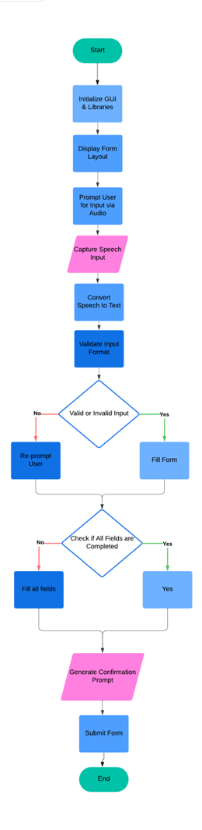

**5. Conclusion:** The "Voice Assistant for Form Filling" project demonstrates the integration of voice recognition technologies to improve user experience. By combining Python libraries like gTTS, tkinter, and speech recognition tools, the application effectively reduces manual effort while maintaining accuracy through input validation mechanisms. Future enhancements could include multilingual support and integration with cloud-based form systems for real-time data synchronization.